**California University of PA**

**Dept. of Computer Science, Info Systems, and Engineering Technology**

**ACSC 455 Structures of Programming Languages**

**Spring 2023**

**= Homework =**

**Assignment 5**

**Andrew Bissell**

**Date Submitted: 02/24/2023**

**Question 1:** Write a C program that has the following statements, and use two-way parameter to increase variable “a” by 10 in fun(). You can have fun() return any value. Run your program on Windows OR Mac, and explain the results.



**Answer 1:** When the expression b = a + fun() and b = fun() + a are evaluated in both instances fun() is evaluated before the addition. Which means that a is 10 when it is passed by two-way parameter to the function and while it’s in the function it is increased by 10. This will cause the expression to be b = 20 + 5 which is b = 25. The variable a will be increased before the addition in both instances and then the return of the functions 5 will be added to it. I can see this being an issue if you aren’t wanting a to change but need it to compute something in the fun() that is necessary for the program.

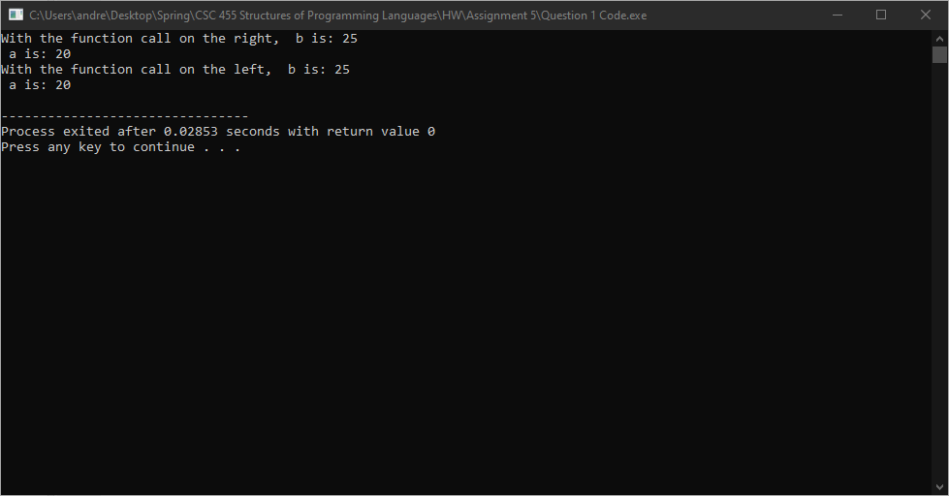

**Question 2:** Write a C program to test your computer uses Short-Circuit Evaluation or not. Explain the results.

**Answer 2:** The test program would short-circuit the rest of the expression for both instances of the first part of the expression being true for the OR statement. The increment of b would never occur and when b is printed after the expression it is always the value given to it before the expression.

